## SAMPLE RECEIVING

|  |  |
| --- | --- |
| User Name: ……………………………………………. | Trainer Name: Ruchira Ariyasinghe |
| User Sign. : ……………………………………………. | Trainer Sign. : ……………………………………………. |

##### SAMPLE RECEIVING

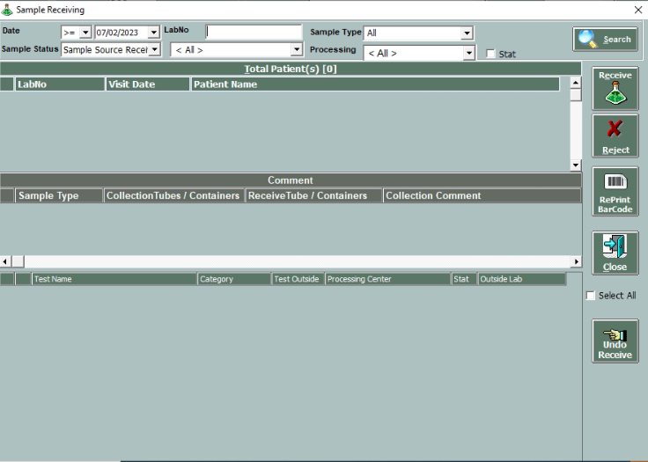

* After generation of Barcode, Sample is sent to the receiving area. This can be in any of the client branches. The receiving module helps to keep track of the samples that reach a particular branch. Also, user can manage the processing centres for each branch using this module. After choosing the processing centre for each sample, the user clicks on ‘Receive’ button
* User can search Subject registration by typing in the patient ID in the ‘Patient ID’ text-box next to the date selection.
* The user can search based on sample types and categories as well
* Sorting of Subjects by sample status is also possible, by default the status will be selected as ‘COLLECTED’.
* User can change processing centres
* Rejection can be done by user by putting appropriate reason. (E.g. Sample haemolysed, Sample not sufficient etc.). Rejection details can be entered in the ‘Comment’ field.

